Global Forest Analysis
1990-2023
AWS Cloud Project Report

AWS Services : S3 / AWS Glue / AWS Crawler / AWS IAM Role / AWS Athena / SQL
Power BI : Power query / Dax/ Dashboard

Project Overview

The Global Forest Data Analysis Project focuses on analyzing and visualizing global forest coverage and changes over time using cloud-based AWS services. The project involves collecting, storing, processing, and analyzing forest-related data to identify trends in forest area across different countries and years.
AWS services are used to provide a scalable and reliable environment for managing the dataset and performing data-related operations. The processed data can then be used to create meaningful visualizations and dashboards that help users understand global forest trends, identify changes in forest coverage, and support data-driven environmental analysis.
The project demonstrates how cloud computing, data analytics, and visualization can be combined to transform raw environmental data into useful insights.

Key Objectives

- Collect and organize global forest data.
- Store and manage the dataset using AWS cloud services.
- Process and analyze forest coverage data.
- Identify changes and trends in forest area over time.
- Create meaningful visualizations and dashboards.
- Demonstrate the use of AWS for a real-world data analytics project.

AWS Services :

Step 1:

Create AWS Management Account and login using credentials

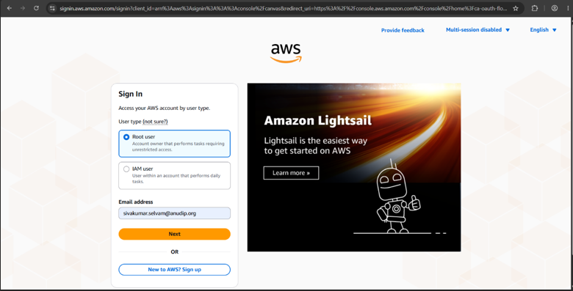

Step 2:

In search – enter – s3 bucket

S3- Simple Scalable Storage

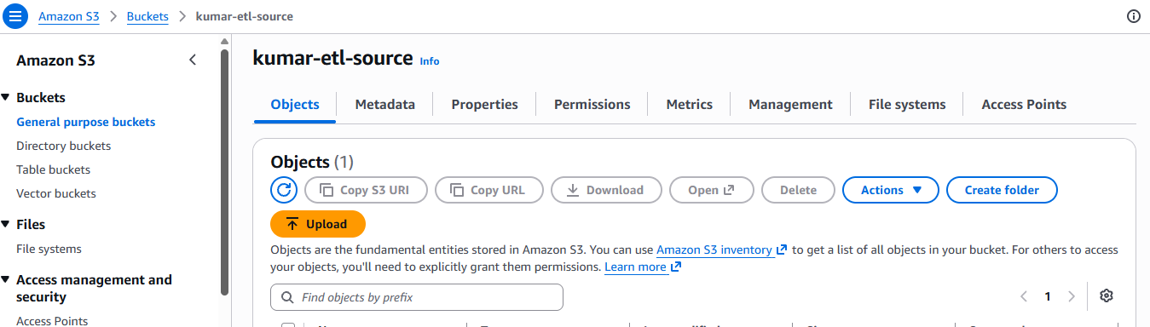
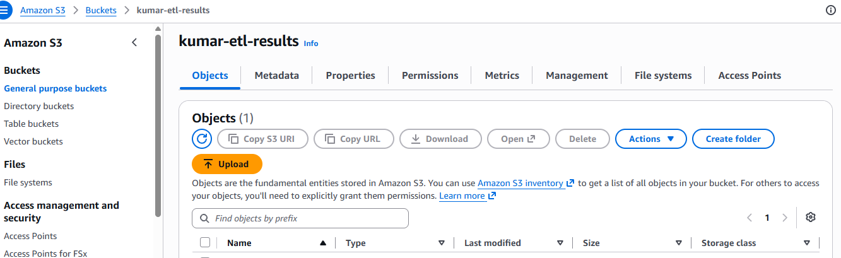

I created two buckets

1.kumar-etl-source - To upload the data set
2.kumar-etl-results – To save the results

Step 3 :

Inside the bucket (kumar-etl-source) – create folder- add file

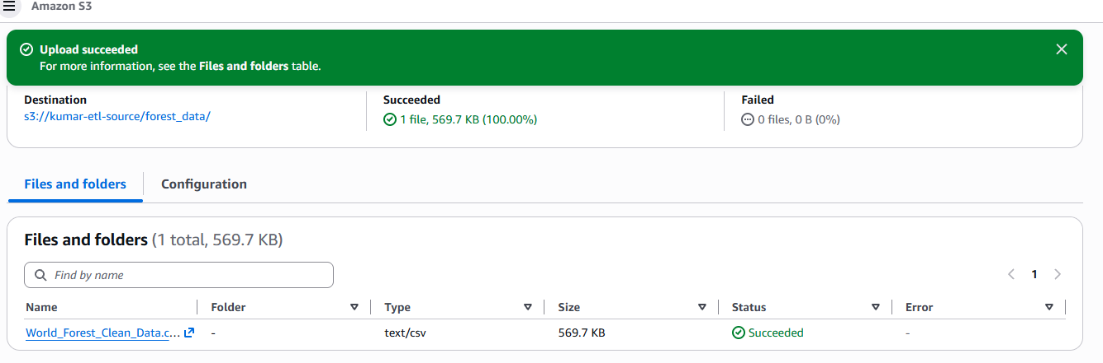
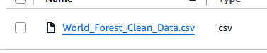
Step 4 :

Create a IAM Role
Assign permission to glue service for access the buckets

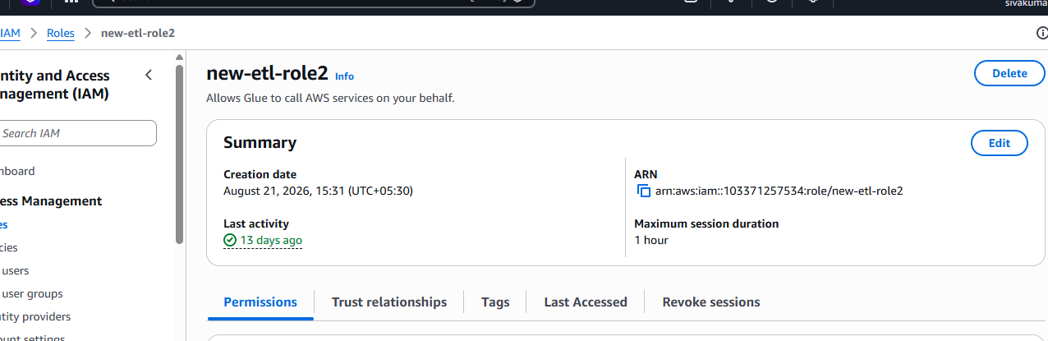

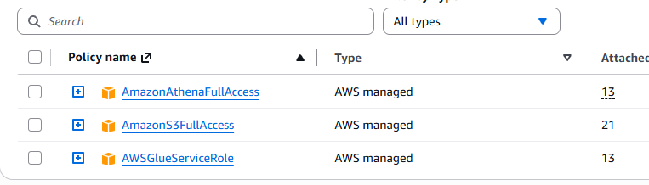

Step 5 :

In AWS Glue service

- Create Crawler
- Database
- Tables
- Create Query

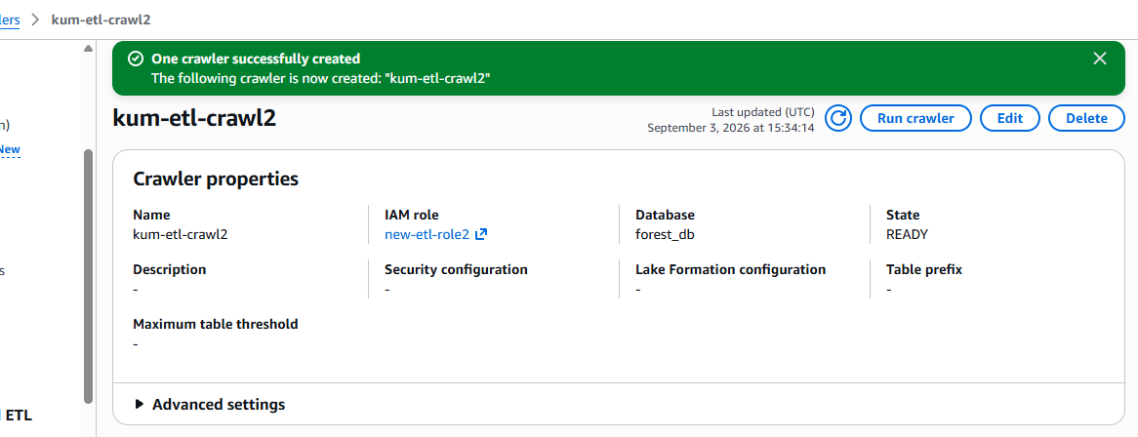

Step 6:

Search Athena and start write query

Athena: Serviceless, interactive query service that lets you analyze data directly in Amazon S3 using standard SQL.

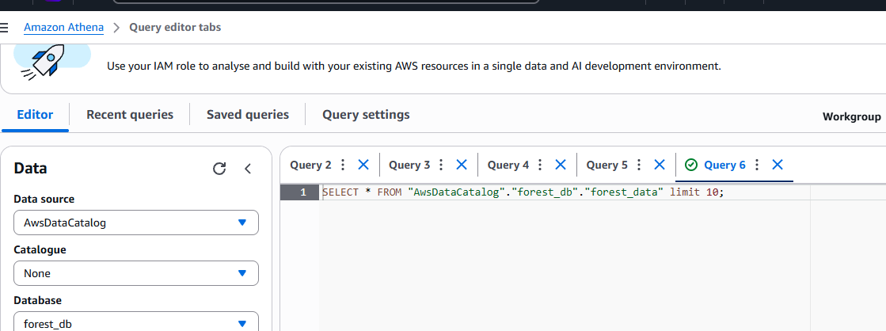

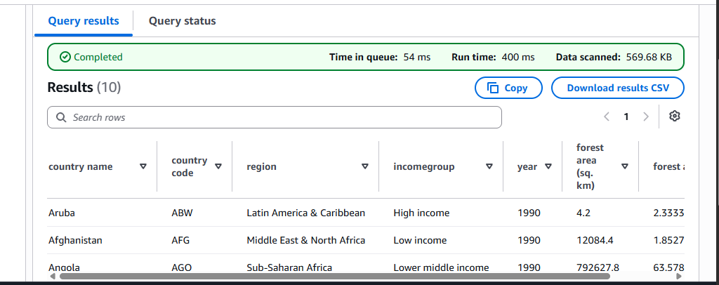

I retrieve the data of forest_data using athena.

Step 7:

I changed column names

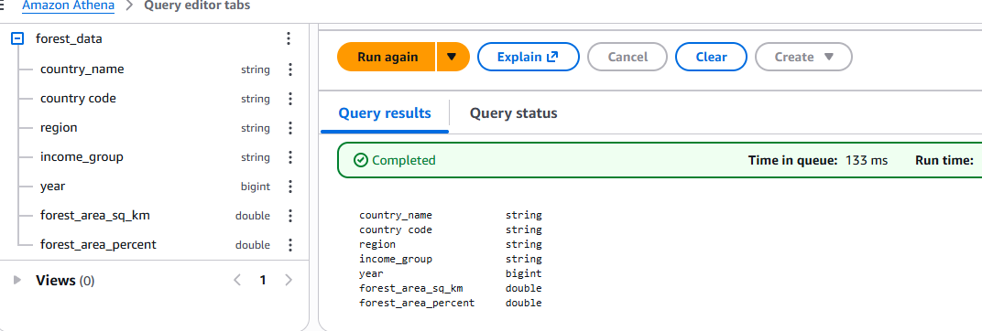

SQL Queries I have performed:

- Region wise total forest area

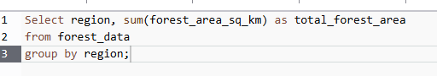

2. Region wise total forest percent

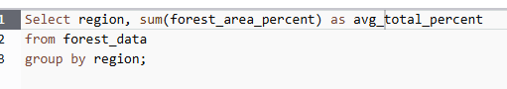

3. Country wise total forest area

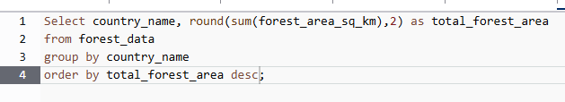

4. Country wise maximum forest area percent

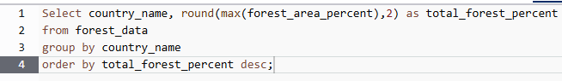

5. Country wise average forest area percent

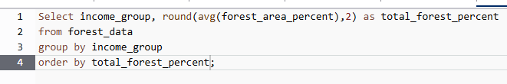

6. Average of forest area percent by income group



7. Total forest area by income group

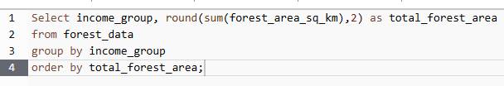

Step 8:

I connect the dataset to power bi through ODBS Software.

- Installed the Simba Amazon Athena ODBC driver on windows
- This ODBC connection allows Power Bi to query the Athena table directly.

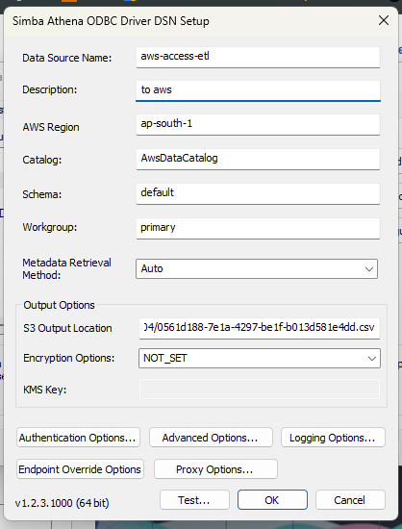

Step 9:

Created an interactive dashboard using Power Bi

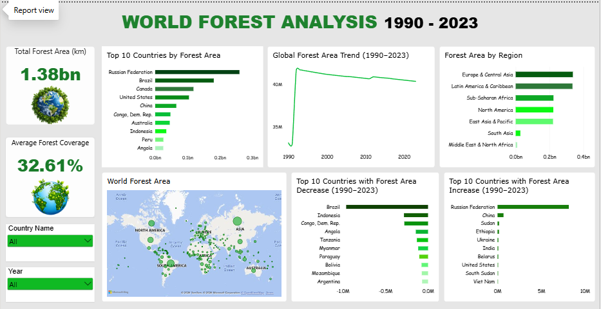

- Collected data from the World Bank containing global forest statistics.

- Removed unnecessary/empty columns from the datasets.

- Identified countries with missing forest data.

- Imported the cleaned dataset into Power BI.

- Created KPI cards for:
Total Forest Area
Forest Coverage

- Created Power BI visualizations:
Top 10 Countries by Forest Area
Global Forest Area Trend
Forest Area by Region
World Forest Area Map
Top 10 Countries with Forest Area Decrease
Top 10 Countries with Forest Area Increase

Insights

- Global forest area in the analysed dataset is approximately 1.38 billion sq. km.

- The average forest coverage across the analysed countries is around 32.61% of land area.

- Russian Federation has the largest total forest area, followed by Brazil, Canada, United States, and China.

- Europe & Central Asia has the highest regional forest area in the dashboard, followed by Latin America & Caribbean and Sub-Saharan Africa.

- Suriname has the highest forest coverage percentage in 2023, with approximately 94.45% of its land covered by forest.

- Brazil experienced the largest forest-area decrease between 1990 and 2023 among the countries shown in the dashboard.

- Indonesia, Democratic Republic of the Congo, Angola, and Tanzania also recorded significant decreases in forest area.

- Russian Federation shows the largest forest-area increase in the dashboard, followed by China and Sudan

- India's forest coverage increased from approximately 21.50% in 1990 to 24.54% in 2023, an increase of about 3.03 percentage points.

- The dashboard shows that total forest area and forest coverage percentage are different measures—a country can have a huge forest area but a relatively lower percentage of its total land covered by forest.

- The 1990–2023 trend provides a long-term view of how forest area has changed across the analysed countries and regions.

- The interactive Country and Year filters allow users to explore forest conditions for individual countries and different years.

Conclusion :

The Global Forest Data Analysis Project successfully demonstrates how AWS cloud services and data analytics tools can be used to transform raw forest data into meaningful insights. The dataset was cleaned, stored, queried, and analysed using cloud-based technologies, with Amazon S3 used for data storage and Amazon Athena used to perform SQL-based analysis.

The analysis helped identify forest coverage patterns, changes over time, and differences between countries and regions. The processed data was further visualized using Power BI, making complex environmental data easier to understand through interactive charts and dashboards.

Overall, this project highlights the importance of data analytics and cloud computing in understanding global forest conditions. The insights can support better environmental awareness, forest management, and data-driven decision-making for sustainable development.

